**Requirements for Text Based Adventure**

. In our text based adventure, we will use the command line interface.

. Directions for where to go, such as North, South, East, and West, which is what the player will use to direct where to head within the game.

. Actions such as Get, which is where the user will come across a New Item and either take it or leave it alone. Look, where the user will observe their surroundings. Attack will be used to Attack enemies within the game.

. The player will have an Inventory to access, and use the Items that are stored within it. 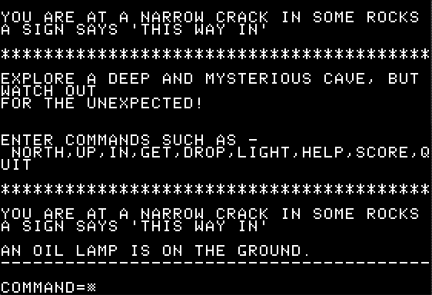

. This is how we expect the game to look within the command line.

. We will also have the player have a Help option to help give them the commands they can use inside the game.

